SULIT



SECP2523 DATABASE

SESSION 2024/2025 - SEMESTER 1
````

ALTERNATIVE ASSESSMENT REPORT: PHASE 2

Name | IMAN ABADI BIN MOHD NIZWAN
IC No. / Matric No. | 040510010353/A23CS0084
Year / Program | 2/SECPH
Section | 01
Lecturer Name | Dr Rozilawati binti Dollah @ Md Zain
Case Study | Lembaga Kemajuan Pertanian Kemubu’ (KADA) Cooperative
System Name | KADA’s Cooperative Web-Based System
Group Name | AlphaTech

SECTION C (SQL AND INTERFACE IMPLEMENTATION)

3.1 | SQL Statement (DDL & DML)  CREATE TABLE `tb_statement` (  `statement_id` int(11) NOT NULL,  `mem_modal_share` float NOT NULL,  `mem_modal_fee` float NOT NULL,  `mem_fixed_saving` float NOT NULL,  `mem_charity_fund` float NOT NULL,  `mem_saving` float NOT NULL,  `mem_al_bai` float NOT NULL,  `mem_al_innah` float NOT NULL,  `mem_scheme` float NOT NULL,  `mem_carnival` float NOT NULL,  `mem_bp_kenderaan` float NOT NULL,  `mem_road_tax` float NOT NULL,  `mem_id` int(11) NOT NULL,  `clerk_id` int(11) NOT NULL,  `statement_date` date NOT NULL  )
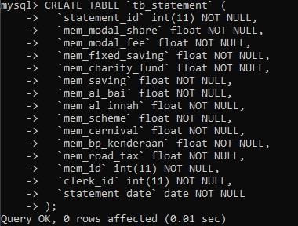

ALTER TABLE `tb_statement`
ADD PRIMARY KEY (`statement_id`),
ADD KEY `mem_id` (`mem_id`),
ADD KEY `clerk_id` (`clerk_id`);

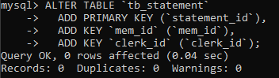

ALTER TABLE `tb_statement`
MODIFY `statement_id` int(11) NOT NULL AUTO_INCREMENT;

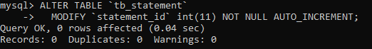

ALTER TABLE `tb_statement`
ADD CONSTRAINT `tb_statement_ibfk_1` FOREIGN KEY (`mem_id`) REFERENCES `tb_member` (`mem_id`),
ADD CONSTRAINT `tb_statement_ibfk_2` FOREIGN KEY (`clerk_id`) REFERENCES `tb_clerk` (`c_id`);
COMMIT;

 |  | 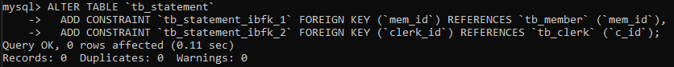
SELECT
tb_loan.loan_name,
SUM(tb_loan_application.la_balance) AS la_balance
FROM
tb_loan
LEFT JOIN
tb_loan_application
ON
tb_loan.loan_id = tb_loan_application.la_type
AND tb_loan_application.la_member_id = 100
GROUP BY
tb_loan.loan_id,
tb_loan.loan_name
ORDER BY
tb_loan.loan_id;

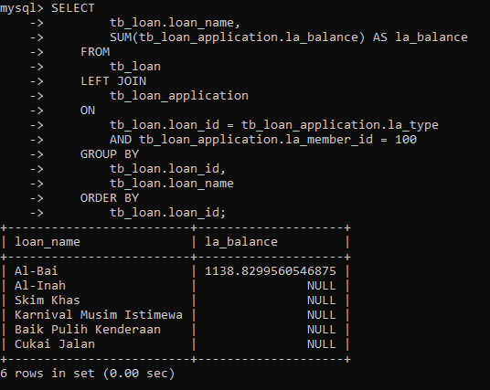

INSERT INTO tb_statement VALUES(2,55,55,55,55,55,1184, 0,0,0,0,0,100,300,'2025-01-01');

SELECT la_id, la_amount_after_interest, la_balance, la_paid, la_monthly_payment, loan_ name FROM tb_loan_application
LEFT JOIN tb_loan ON tb_loan_application.la_type = tb_loan.loan_id
WHERE la_member_id = 100 AND la_status = 4;
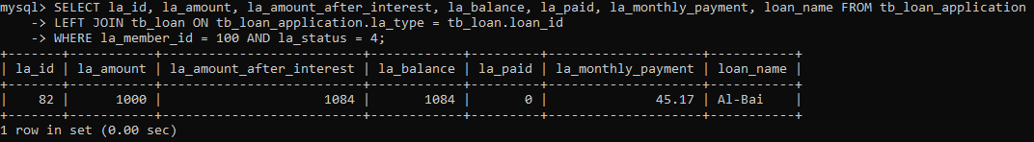

SELECT tb_statement.mem_modal_share, tb_statement.mem_modal_fee, tb_statement.mem_fixed_saving, tb_statement.mem_charity_fund,
tb_statement.mem_saving, tb_statement.mem_al_bai, tb_statement.mem_al_innah, tb_statement.mem_scheme, tb_statement.mem_carnival,
tb_statement.mem_bp_kenderaan, tb_statement.mem_road_tax, tb_statement.mem_id, tb_statement.statement_date, tb_member.mem_name, tb_member.mem_ic
FROM `tb_statement` LEFT JOIN tb_member ON tb_statement.mem_id = tb_member.mem_id
WHERE tb_statement.mem_id = 100 AND statement_date = '2025-01-01';
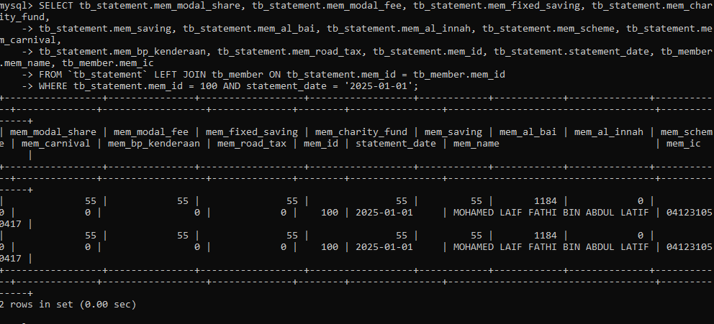

SEELCT mem_modal_share, mem_modal_fee, mem_fixed_saving, mem_charity_fund, mem_saving
FROM tb_member
WHERE mem_id = 100;
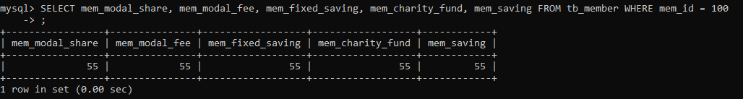

SELECT fee_id, fee_entry, fee_modalshare,fee_modalfee, fee_fixed_saving, fee_charity, fee_savings, fee_other, fee_month FROM tb_fee_payment WHERE fee_member_id = 100
ORDER BY fee_month DESC;

SELECT tb_loan_application.la_id, tb_loan_application.la_type, tb_loan_application.la_amount,
tb_loan_application.la_status, tb_loan.loan_name, tb_appstatus.app_desc FROM tb_loan_application
LEFT JOIN tb_appstatus ON tb_loan_application.la_status = tb_appstatus.app_id
LEFT JOIN tb_loan ON tb_loan_application.la_type = tb_loan.loan_id
WHERE tb_loan_application.la_member_id = 100;
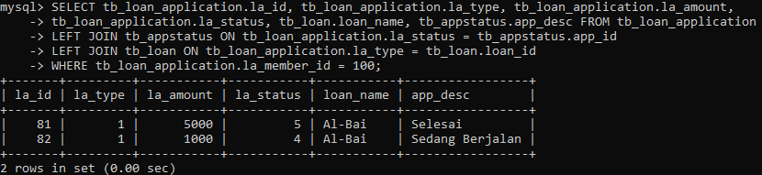

3.2 | Interface Implementation
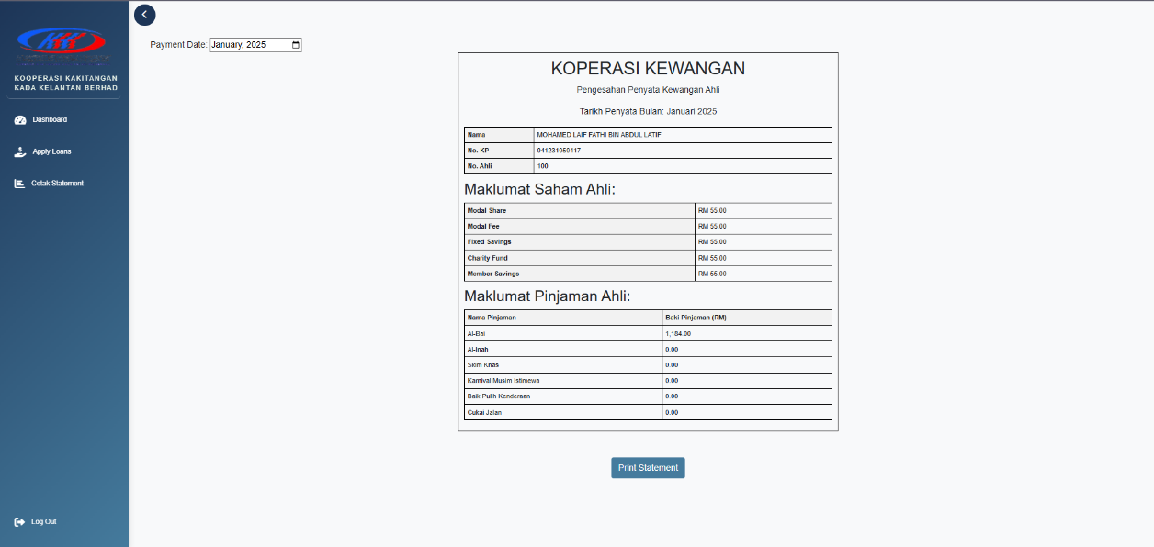

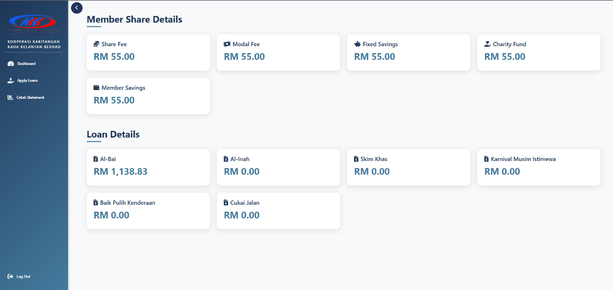

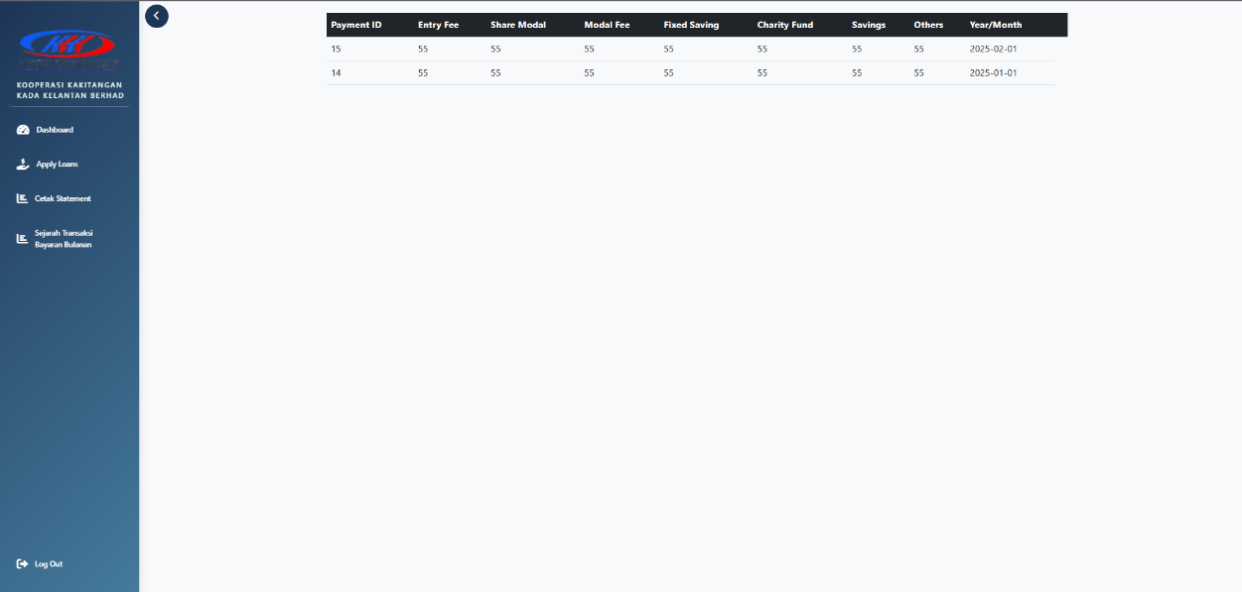

SECTION D (CONCLUSION AND REFLECTION)

4.1 | Conclusion
 |  | In conclusion, the module produced gave expected result based on what was proposed. The member can view financial statement detailing their shares and loan balance and viewing transactions that were made from both loan repayment monthly fees. For future improvements, the system could provide charts for past payments and alerts for future payments or when a payment has been made. It could also benefit from payments made directly though the app instead of payments from salary deduction and upfront payment.
4.2 | Reflection
Description (Pure Fact)

The project involves the Lembaga Kemajuan Pertanian Kemubu’s (KADA) Cooperative. The cooperative is an organization within KADA that allows the employees of KADA to become a member of the cooperative to enjoy benefits such as stock exchange where they can earn dividends based on profits that the cooperative earns in that year. Other than that, the cooperative also has a loan lending service that members can apply for. To become a member and apply for loan, both membership and loan application requires the authorization of a member of the board of directors before they can be approved. The member should also have a minimum of RM 300 before they can apply for a loan. The problem the cooperative is facing is that they still use the manual approach to handle all the business processes mentioned above. Thus, WBL project was done to overcome the problem. Requirements for the system were gathered through an online meeting to determine the specification of the system. A representative of the cooperative was interviewed to gather the information needed. The requirements are then designed to determine an appropriate design for the system before the developments phase was done. This is to reduce error during the development phase. The database of the system was designed first to ensure data accuracy that only stores relevant and valuable information. After the database was designed the system was divided into multiple modules where each member of the team is responsible for the modules they are assigned to. I worked on the financial module which consists of 3 use cases.

Descriptions (Feelings)

Throughout the development of the project, I was feeling anxious as this is my first major project. As the team leader, this also made me feel more anxious as my team members rely on me for this project. I found that clarity on the subject matter improves the of both me and my teammates understanding of the project. Clarity in proper database design and code implementation has helped the progress of the development.
There were difficulties such as unclear design requirements provided by the client that created some initial confusion. Furthermore, our limited knowledge on system development also posed a challenge early on. Despite the challenges, the team made it through a rather significant progress after the confusions were resolved.

Evaluation

From this project, I get to learn all the technologies used in web development, the process of developing a system and the importance of having a proper database design which I find to be a valuable experience and knowledge gained. From the difficulties mentioned before, I find it a bad experience to constantly make adjustments to our database design as it sometimes changes a large structure of the code that was developed before. Because of this, I made it my mission to first determine the proper requirements and database design to reduce the need for adjustments in the future by planning out the flow of the use cases. There are circumstances that have affected my actions throughout my project such as other assignments from other subjects that limited my time focusing on this project.
Analysis

From the experiences, I have determined that my main area of concern is in database design and development as I still find myself lacking in producing an affective database. I strive to resolve this issue by doing further studies on the topic as to not run into the same problems in future projects.

Conclusion

In conclusion, I have discovered that this project has been an invaluable experience for me as I get to test the knowledge that I have learned the past semester on applying it to the project. I have also discovered my weaknesses while doing the project on both technical skills and team working skill. Often times I tell myself that I should have tried to communicate better with my teammates so that a more desirable result could have been produced. However, I take it as a lesson for me to be better in the future.

Self-criticism

In upcoming projects, I strive to better equip myself with relevant knowledge beforehand and also to improve my leadership and teamworking skill. I find that effective preparation and communication is the goal to a successful project. I will try to communicate with my teammates better and listen to their difficulties to resolve it faster.

